Abubakkar Abdullah
20p-0045
Section-5B
BCS
Lab-12 Task
Diagramatically:
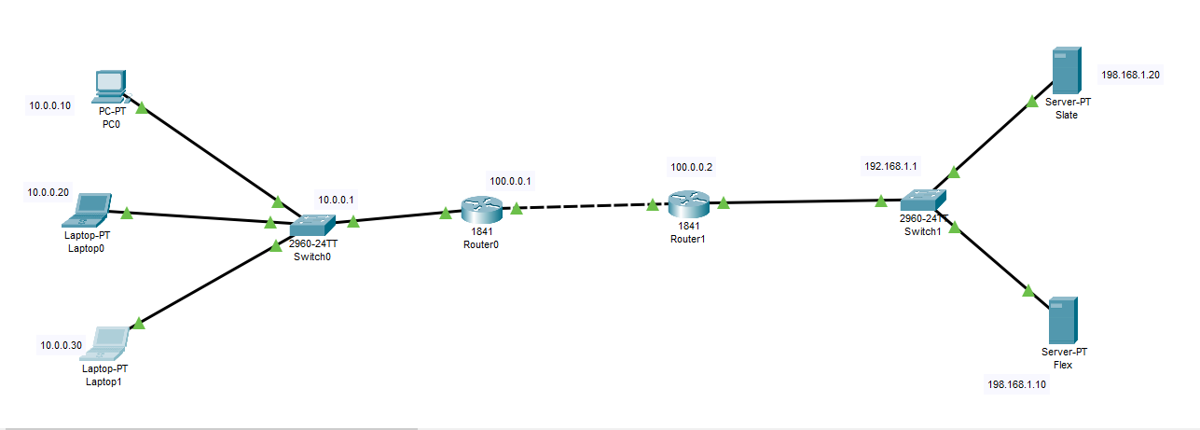.

Diagramatically:

.

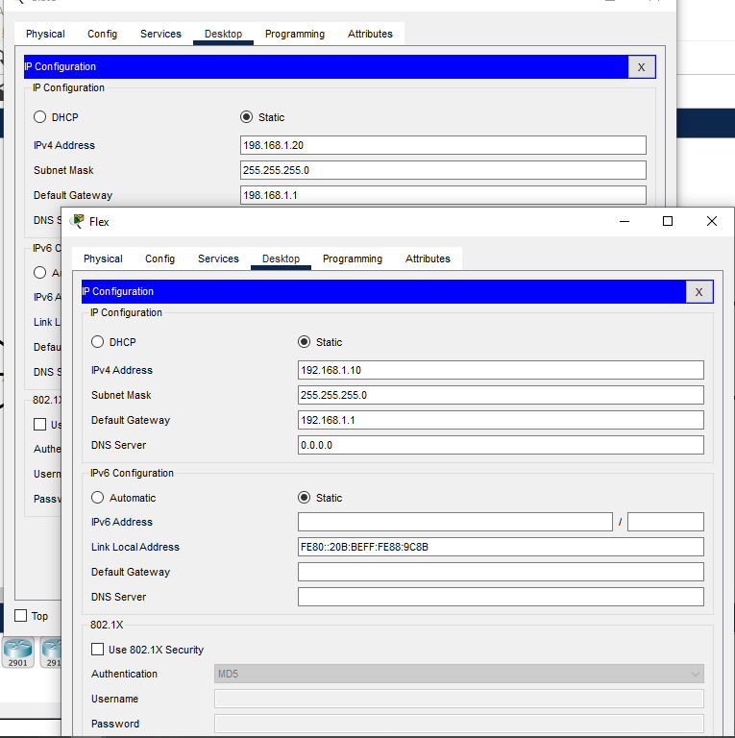.

Diagramatically:
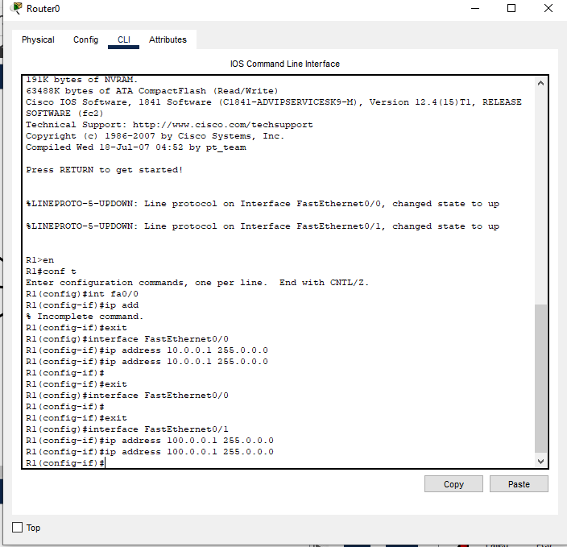
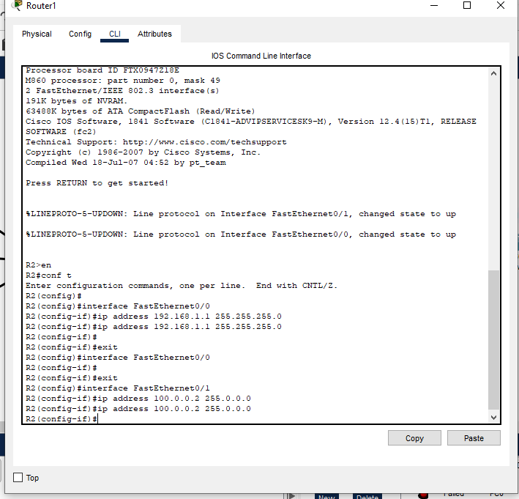

NAT Working:
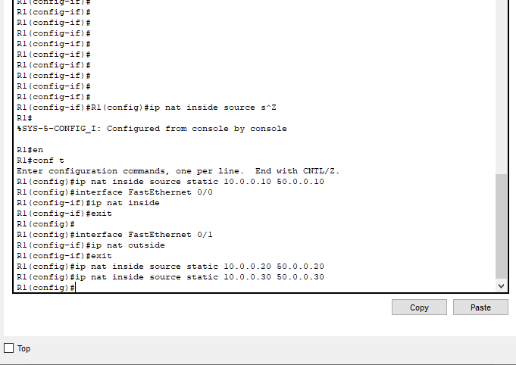

NAT WORKING FOR ROUTER 2:

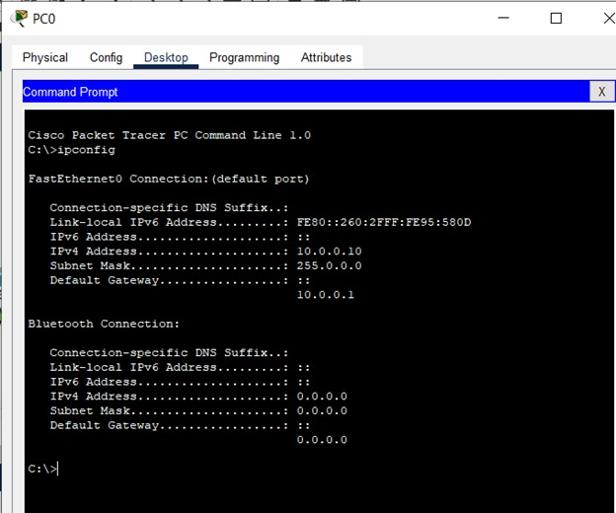
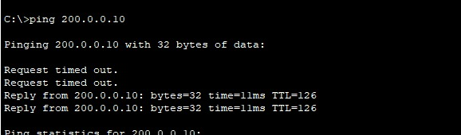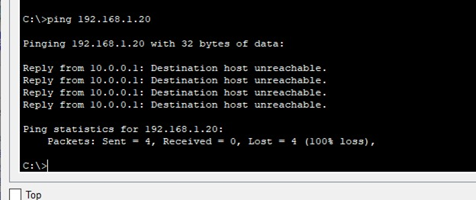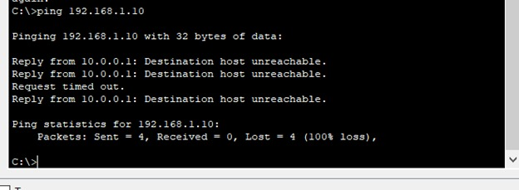.
PING TEST BETWEEN COMPUTERS IS SUCCESSFULL

